|  |  |  |
| --- | --- | --- |
|  | https://www.yachtingnz.org.nz/sites/yachtingnz/files/styles/club_logo/public/group_logo_images/Class%20association%20marauder%20Logo.jpg?itok=PJgBFhIo |  |

# Marauder 8.4 Class Championship 2025

# Farr 1020 Race Weekend

Saturday 12thApril and Sunday 13th April 2025

The Organising Authority is the Weiti Boating Club Inc, Fairhaven Walk Whangaparaoa.

Ph. (09) 424 5905 [www.weiti.co.nz](http://www.weiti.co.nz) [info@weiti.co.nz](mailto:info@weiti.co.nz)

## **SAILING INSTRUCTIONS**

1. **RULES**
   1. The event will be governed by the rules as defined in the *Racing Rules of Sailing (RRS).*
   2. The Yachting New Zealand Safety Regulations Part II, **Category 4** shall apply.
   3. All yachts must be equipped with a VHF radio capable of transmitting and receiving on all channels.
   4. Extras:
2. Extras are defined as sails not usually used to advantage to windward.
3. Divisions 1 & 3 boats only may fly extras, (no more than 2 spinnakers shall be carried).
4. Division 2 is non-spinnaker (no extras).
   1. The Marauder Class Rules will apply with the following exceptions:
5. Keel stepped masts will be permitted.
6. No 1 genoa may be hanked, foiled or furled.
7. No 2 genoa must be smaller than No. 1 but does not need to conform to the class size. However, only one No. 2 genoa may be included in the sail wardrobe for this event.
   1. Code of Conduct: Competitors shall comply with any reasonable request from an event official.
8. **CHANGES TO SAILING INSTRUCTIONS**
   1. Any change to the Sailing Instructions will be posted before 0900 hours on the day it will take effect, except that any change to the schedule of races will be posted by 1800 hours, or at the end of the protest time, whichever is the earlier on the day before it will take effect.
9. **COMMUNICATION WITH COMPETITORS**
   1. Notices to competitors will be posted on the official notice board at the   
      Weiti Boating Club.
   2. On the water, the race committee intends to monitor and communicate with competitors on VHF radio channel 77. The race committee call sign is “Weiti Race Control”.
   3. The following communications will be made by the race committee on VHF channel 77:

Time checks, location of race committee vessel, change of course, shortening, postponement, abandonment, starting signals, recalls, next warning signal time.

* 1. Except in an emergency, a boat shall neither make radio transmissions while racing nor receive radio communications not available to all boats. This restriction also applies to mobile telephones.

1. **SIGNALS MADE ASHORE**
   1. Signals made ashore will be displayed on the flagpole at the WBC Clubrooms.
   2. When flag AP is displayed ashore, '1 minute' is replaced with 'not less than 60 minutes' in race signal, AP.
2. **SCHEDULE OF RACES**

Day Date No. of Races First Warning Signal

Saturday 12th April 2025 Up to five W/L races 0855 Marauder

0955 Farr 1020

Sunday 13th April 2025 One Harbour race 0855

In the event that there is no racing on the Saturday, up to 5 W/L races will be held on Sunday.

* 1. To alert boats that a race or sequence of races will begin soon, the orange starting line flag will be displayed with one sound at least five minutes before a warning signal is made.
  2. No warning signal will be made after 1400 on Sunday 13th April 2025.

1. **CLASS AND DIVISON FLAGS**

Class flag displayed by race management -

* 1. Marauders – the class insignia on a white background.

Farr 1020 – the class insignia on a light blue background.

* 1. Boats shall display a division flag:

1. Marauder Division 1 Spinnaker boats Yellow Flag
2. Marauder Division 2 Non Spinnaker boats Green Flag
3. Marauder Division 3 Non Standard boats White Flag
4. Farr1020 Division 1 Spinnaker boats Blue Flag
5. Farr1020 Division 2 Non Spinnaker boats Black Flag
6. **RACING AREA**
   1. Racing will be held in the area southof the Whangaparaoa Peninsula.
7. **COURSES**
   1. The diagram in attachment 1 shows the Windward / Leeward (W/L) courses.
   2. The diagrams in Attachment 2 shows Harbour courses.
   3. No later than the warning signal, the race committee signal vessel will display the course number and the approximate compass bearing and distance to Mark 1.

1. **MARKS**
   1. Marks for the Windward/Leeward Course are described in Attachment 1.
   2. The starboard end of the starting line will be a race committee vessel.   
      The port end of the starting line will be a pink cylindrical buoy.
   3. For windward leeward races, the Starboard end of the finishing line will be a race committee vessel. The port end of the finishing line will be a blue cylindrical buoy.
2. **THE START**
   1. The starting line will be between a staff displaying an Orange flag on the race committee vessel at the starboard end and a pink cylindrical buoy at the port end.
   2. For the first race of the day all Farr 1020 divisions will start together under the Farr 1020 Class Flag followed five minutes later by all Marauder divisions starting together.
   3. A boat that does not start within four minutes after her starting signal will be scored Did Not Start without a hearing. This changes RRS A5.1 and A5.2.
   4. If any part of a boat’s hull is on the course side of the starting line at her starting signal and she is identified, the race committee will attempt to broadcast her name and/or sail number. Failure to make a broadcast, failure of her to hear such a broadcast, or the order in which the boats are broadcast will not be grounds for a request for redress. This changes Racing Rules of Sailing 62.1(a)
3. **CHANGE OF THE NEXT LEG OF THE COURSE**
   1. For the Marauder Class, there will be no course changes during a race using RRS 33.
   2. For the Farr 1020 Class, to change the next leg of the course, the Race Committee will move an original mark.
4. **THE FINISH**
   1. For windward leeward courses the finishing line is between a staff displaying a Blue flag on the race committee vessel at the starboard end and a blue cylindrical buoy at the port end.
   2. For harbour races the finishing line is between a staff displaying a Blue flag on the race committee vessel and the yellow southern marine marker northeast of Toroa Point.
5. **Penalty System**
   1. Rule 44.1 *Taking a penalty*, is changed so that the Two-Turns Penalty is replaced by the One-Turn Penalty.
6. **Time Limits and Target Times**
   1. Time limits and target times in minutes for the first boat are as follows:

|  |  |  |  |
| --- | --- | --- | --- |
| **Course** | **Time Limit** | **Target Time** | **Finishing Window** |
| **Windward/ Leeward (W/L) 2 & 3** | 90 mins | 45 mins | 30 minutes |
| **Harbour Courses** | 240 mins | 3 hours | 60 minutes |
|  |  |  |  |

* 1. Boats failing to finish within the Finish Window after the first boat starts, sails the course, and finishes within the race time limit will be scored Did Not Finish without a hearing. This changes rules 35, A5.1 and A5.2

1. **HEARING REQUESTS**
   1. For protests where only a rule of part 2 or rule 31 are alleged to have been broken, an arbitration hearing will be offered prior to any formal hearing. (This changes Rule44.1). The scoring abbreviation for a penalty accepted at an Arbitration hearing is ARB.
   2. Protest forms are available at the race office (Weiti Boating Club). Protests and requests for redress or reopening shall be delivered to the race office within the appropriate time limit.
   3. The protest time limit is 120 minutes after the last boat has finished the last race of the day.
   4. Competitors involved in protests will be informed by phone and/or email of the time hearings will take place.  Hearings will be held at the Weiti Boating Club rooms.
   5. Notices of protests by the race committee or protest committee will be posted to inform boats under rule 61.1 (b)*.*
2. **SCORING**
   1. One (1) race is required to be completed to constitute a series.
   2. The low points scoring system of the racing Rules of Sailing Appendix A shall apply.
   3. Where five (5) W/L races are completed, a boat’s series score will be the total of her race scores excluding her worst score.
   4. For Marauders: Single handed entries are only required to complete up t four (4) W/L races. No discard will apply.
   5. Discard cannot apply to harbour race.
3. **SAFETY REGULATIONS**
   1. A boat that retires from a race must notify the race committee as soon as possible, either directly or via VHF channel 77, call sign “Weiti Race Control”.
   2. All entrants are required to register with the committee vessel via VHF Radio before the warning signal for the first race of the day, advising the boat name and the number of people on board.
   3. Boats may be inspected for compliance with the safety regulations at the discretion of the race committee.
   4. **Skippers are required to maintain a written list on board of all crew for the day (including the skipper), their next-of-kin or contact person, and a contact phone number.**  All crew must be made aware of the location of this list before departing their mooring.
   5. **All entrants must provide the names of all crew to Peter Melvin (WBC)**   
      **on Mob: 027 230 2162 or email** [**peterkmelvin@gmail.com**](mailto:peterkmelvin@gmail.com) **prior to the commencement of the regatta.**
   6. **For all races sailed Single Handed the following additional safety regulations apply:**

* Skippers must wear an approved life jacket while racing.
* Skippers must carry on their person a means of communication to self-initiate a rescue in the event that they fall overboard.
  1. The Organising Authority **recommends that ALL competitors wear a Personal Floatation Device (Lifejacket)** that meet New Zealand Standard 5823:2005 (inflatable type 401 150N) with a crotch strap while underway.

1. **EQUIPMENT AND MEASUREMENT CHECKS**
   1. A boat or equipment may be inspected at any time for compliance with the class rules and sailing instructions. On the water, a boat can be instructed by a race committee appointed measurer or representative to proceed immediately to a designated area for inspection.
2. **OFFICIAL VESSELS**
   1. Official vessels will be marked with a WBC pennant.
3. **SUPPORT TEAMS**
   1. Except when requested to participate in rescue operations, team leaders, coaches and other support personnel shall stay outside areas where boats are racing and are restricted to a 5-knot speed limit from the time of the preparatory signal until all boats have finished or retired or the race committee signals a postponement, or abandonment of all races. The areas the boats are racing in is defined as the area inside the course and within 100 meters of any mark, lay line, staffing line, finishing line or any area where any boat that is racing, is sailing or may sail.

**ATTACHMENT 1: Course Diagrams - Windward / Leeward**

Finish

4S

4P

Start

Finish

1

1X

|  |  |
| --- | --- |
| **Mark** | **Description** |
| 1 | Orange Conical buoy |
| 1X | White Conical buoy |
| 4S and 4P | Orange Conical buoys |
| Start mark port end | Pink Cylindrical buoy |
| Start and Finish mark starboard end | Race Committee Vessel |
| Finish Mark port end | Blue Cylindrical Buoy |

|  |  |
| --- | --- |
| **Signal** | **Mark Rounding order** |
| **Farr 1020** | |
| L2 | Start – 1 – 4S/4P – 1 – Finish (Downwind) |
| L3 | Start – 1 – 4S/4P – 1 – 4S/4P – 1 - Finish (Downwind) |
| W3 | Start – 1 – 4S/4P – 1 – 4S/4P – Finish (Upwind) |
|  | |
| **Marauder** | |
| LX2 | Start – 1X – 4S/4P – 1X – Finish (Downwind) |
| LX3 | Start – 1X – 4S/4P – 1X – 4S/4P – 1X - Finish (Downwind) |
| WX3 | Start – 1X – 4S/4P – 1X – 4S/4P – Finish (Upwind) |

**Attachment 2 – Harbour Courses**

**Triangular course**

Mark 1 will be an orange conical buoy laid approximately 1 Nautical Mile to windward of the starting line.

**Course 1** - Approximately 17 Nautical Miles

Start - Mark 1(Starboard) – Gulf Harbour Yellow Mark (Starboard) - Torbay Yellow Mark (Port) – Navy Buoy (Port) - Finish (Southern Marine Marker)

**Course 2** - Approximately 12 Nautical Miles

Start – Mark 1(Port) – Northern Marine Marker (Port) – Gulf Harbour Mark (Starboard)  
 – Middle Marine Marker (Port) – Gulf Harbour Mark (starboard)  
 – Finish (Southern Marine Marker)

**Course 3** - Approximately 14 Nautical Miles

Start – Mark 1(Port) –Gulf Harbour Mark (Starboard) – Northern Marine Marker (Port) –Gulf Harbour Mark (starboard) - Middle Marine Marker (Port) – Gulf Harbour Mark (starboard) – Finish (Southern Marine Marker)

**Course 4** Approximately 15 Nautical Miles

Start – Mark 1(Port) – Navy Buoy (Starboard) – Middle Marine Marker (Port) – Gulf Harbour Mark (starboard) – Finish (Southern Marine Marker)

**Course 5** Approximately 7 nautical miles

Start – Northern Marine Marker (Port) – Southern Marine Marker (Port) – Northern Marine Marker (Port) – Finish (Southern Marine Marker)

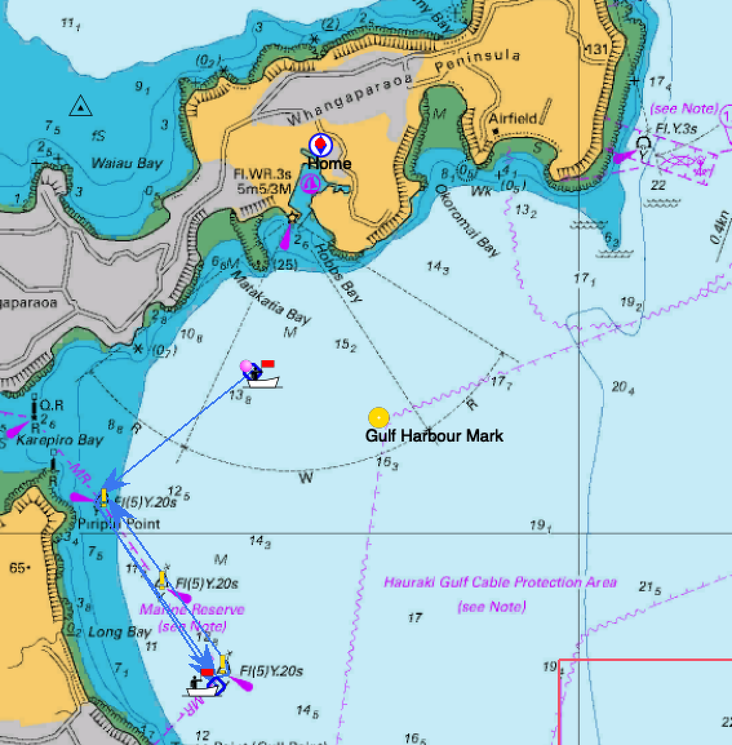

**Course 6** Approximately 10 Nautical Miles

Start – Northern Marine Marker (Port) - Gulf Harbour Mark (Stbd) – Middle Marine Marker (Stbd) - Gulf Harbour Mark (Stbd) – Finish Southern Marine Marker

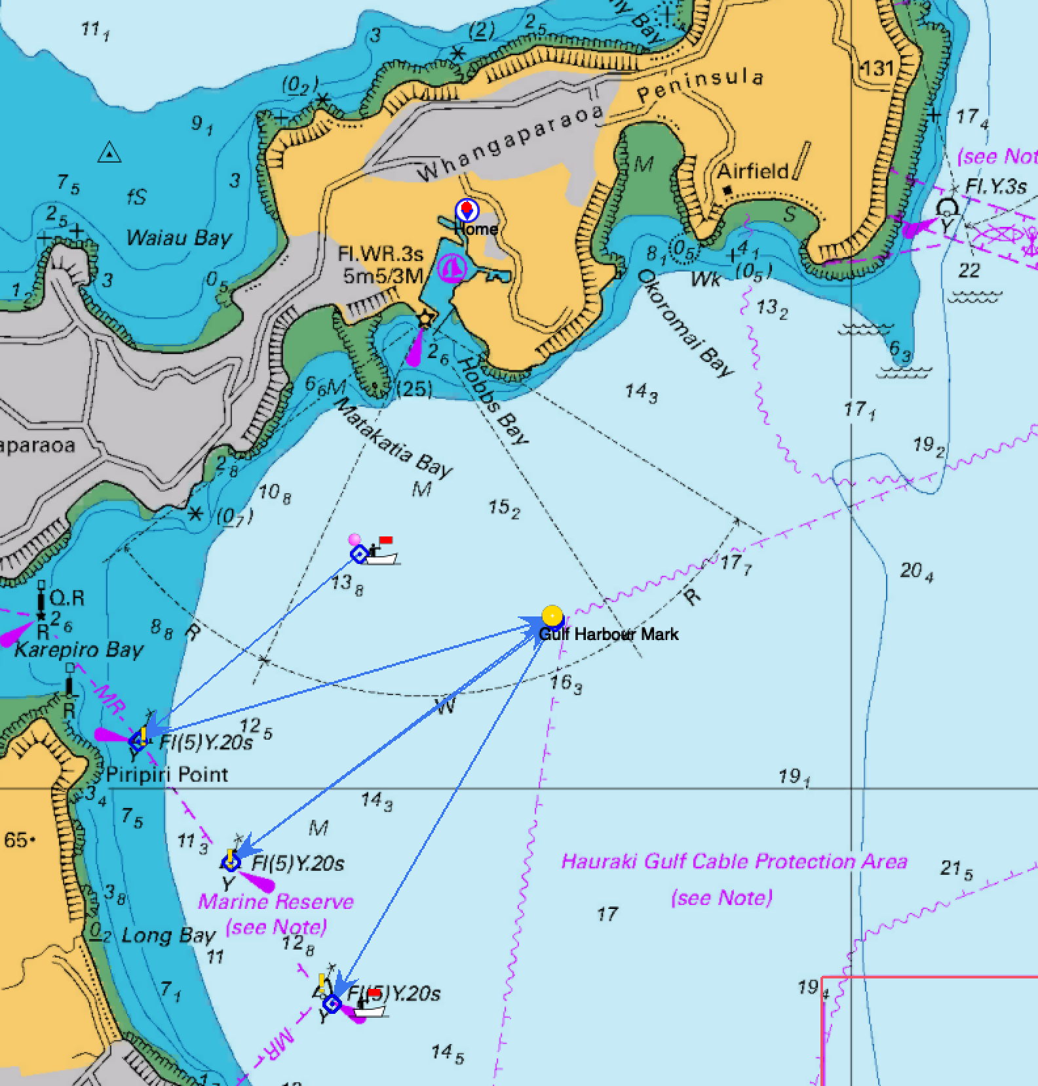

|  |  |  |
| --- | --- | --- |
| **Mark** | **Lat.** | **Long.** |
| GH Buoy (Gulf Harbour Yellow Buoy) | 36 39.130S | 174 48.030 E |
| Torbay Buoy (approx. 1.5 miles east of Torbay) | 36 42.500 S | 174 47.300 E |
| Navy Buoy (Whangaparaoa Outer / Eastern buoy) | 36 36.922S | 174 50.654 E |
| Marine-Nth (Northern Long Bay Marine Reserve marker) Piripiri Point | 36 39.761S | 174 45.282E |
| Marine-Mid (Middle Long Bay Marine Reserve marker) | 36 40.451S | 174 45.900E |
| Marine-Sth (Southern Long Bay Marine Reserve marker) | 36 41.122 S | 174 46.488 E |